MINOR PROJECT REPORT

ON

“ONLINE LIBRARY MANAGEMENT

SYSTEM”



Submitted by:

=>NALAM ANUNAY

2019-BCS-034

under the supervision of

**Dr. Arun Agaria sir**

TABLE OF CONTENTS

1.Abstract

2.Specific Features

3.Technology used

4.Entity relationship daigram

5)project completed till now

6)pending project

7)future scope and application

8.Conclusion

ABSTRACT

*Library management system is a project which aims in developing a computerised system to maintain the daily work of library.*

*This project can generate various options such as*

*1)member login*

*2)librarian login*

*3)new sign up*

*4)member registration*

*5)librarian registration*

*6)complaint box*

*7)fine paid*

*8)fine status*

*9)get librarian information*

*10)get member information*

*11)search book*

*12)insert book*

*13)issue book*

*14)return book*

*15)homepage*

*16)profile update*

SPECIFIC FEATURES

* *A member can request at most for three books*
* *if he has any fine penalty due to late submission of book then that student cannot access books*
* *Member can post a complaint if the required book is not available or any other issue related to Library.*

*Over all this project is being done to help staff of library in the best possible way and also to reduce paper work and human efforts.*

*Technology Used :*

*Front End : HTML,CSS.*

*Back End : My sql, Apache Tomcat server,PHP.*

*ENTITY-RELATIONSHIP DIAGRAM:*



*Project completed till now:*

*1)Home page*

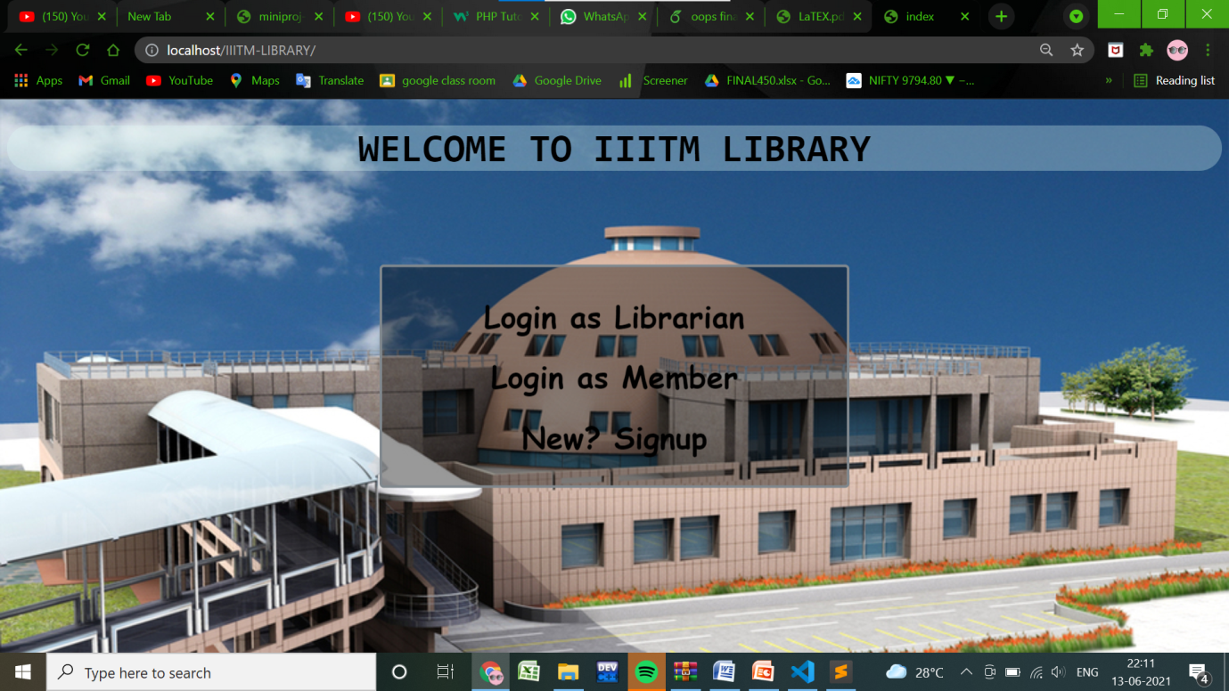

*2)Librarian login*

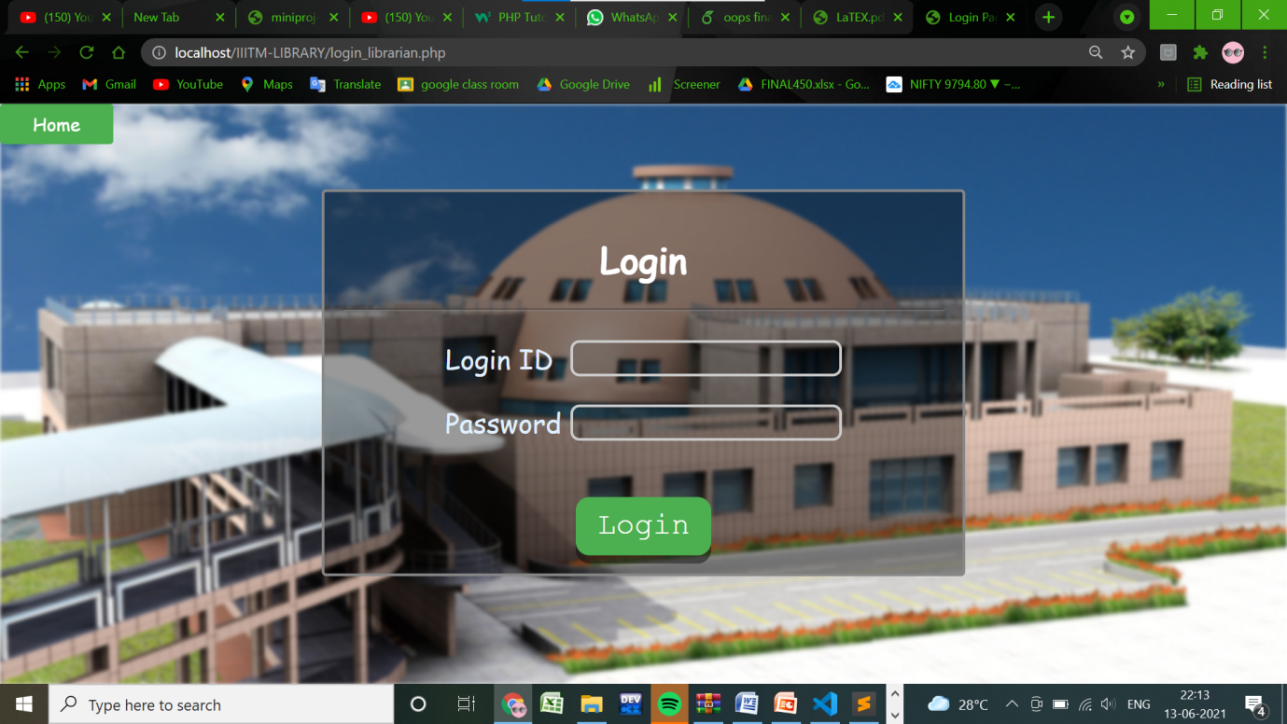

*3)Member login*

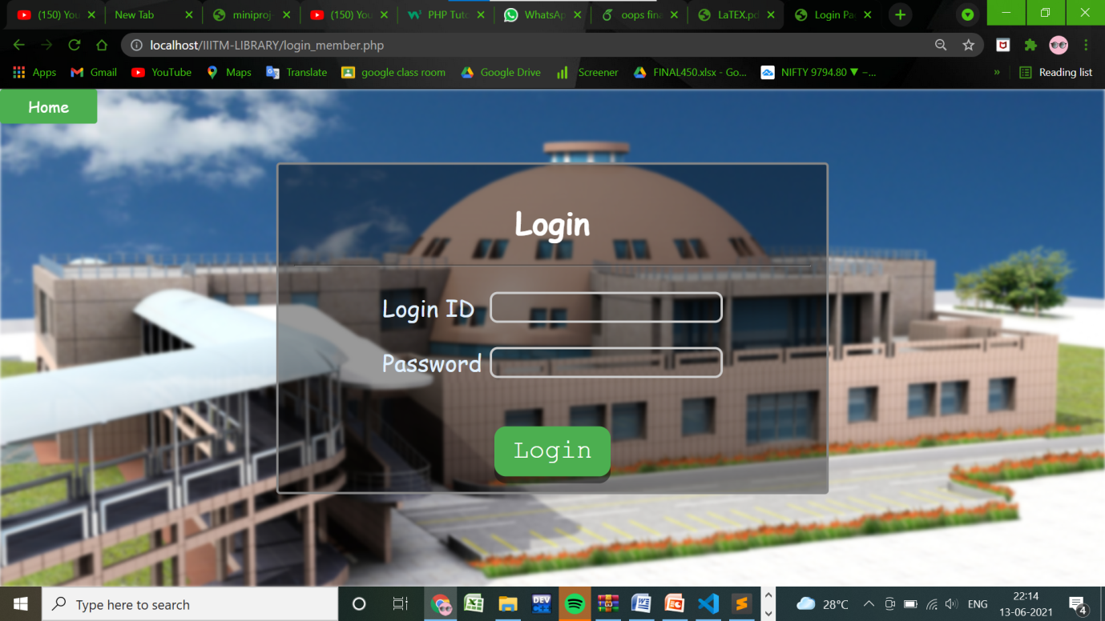

*4)New registration*

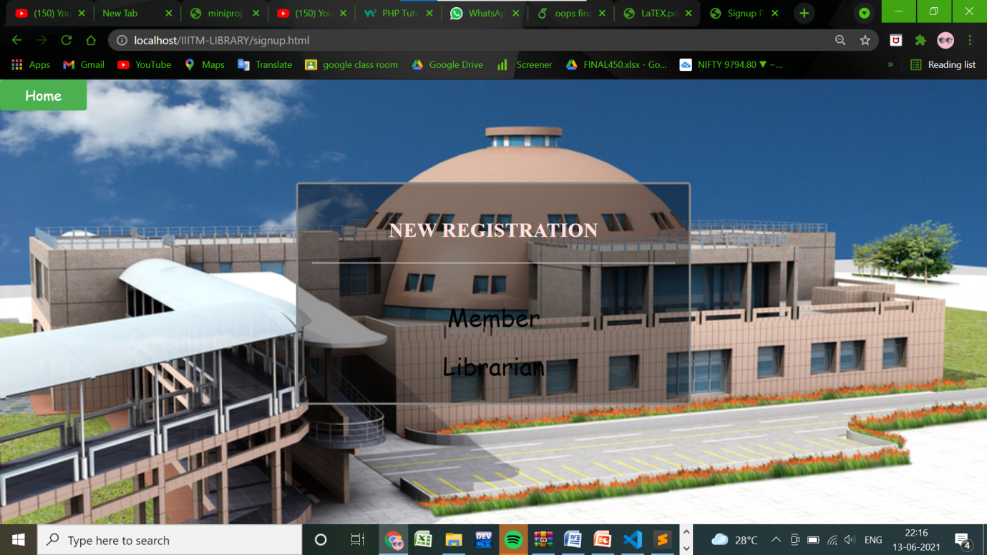

*5) Member signup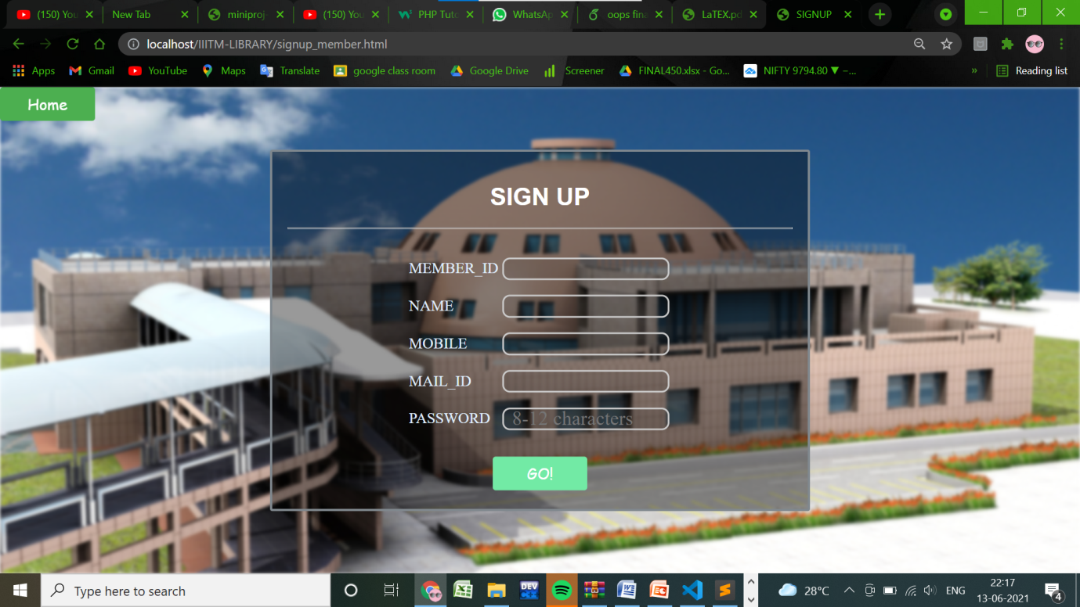*

*6)librarian signup*

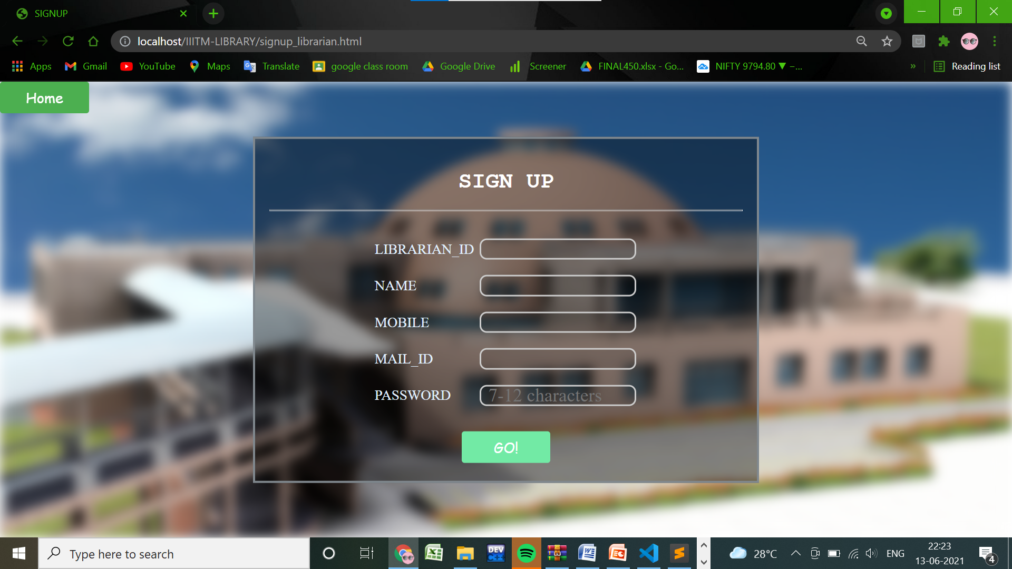

*Pending project:*

*70% of the project was still not completed like data base,complaint box,*

*fine paid,fine status,get librarian information,get member information*

*,search book,insert book,issue book*

*,return book, homepage ,profile update and it will be completed soon.*

*FUTURE SCOPE OF APPLICATION :*

*This website can be easily implemented under various college Libraries.*

*We can add new features as and when we require.*

*Conclusion:*

*From a proper analysis of positive points and constraints on the component, it can be safely concluded that the website is efficient and can be updated when needed*

*This application is working properly and meeting to all user requirements.*